Q1:

<!DOCTYPE html>

<html lang="en">

<head>

<meta charset="UTF-8">

<meta name="viewport" content="width=device-width, initial-scale=1.0">

<title>Introduction</title>

</head>

<body>

<h1>INTRODUCTION</h1>

<label for="Name" style="font-weight: bold;font-size:x-large;">Name : </label>Abdullah Faisal

<br><br>

<label for="Rollno" style="font-weight: bold;font-size:x-large;">Rollno : </label>21F-9213

<br><br>

<h2>BIO : </h2>

<p>I am a 6th-semester student in FAST NUCES and currently working on web programming. <h3>Interests :</h3> <ul><li>Web PRogramming</li><li>Data Science</li><li>App devolpment</li><li>Cricket</li></ul> </p>

<p></p>

</body>

</html>

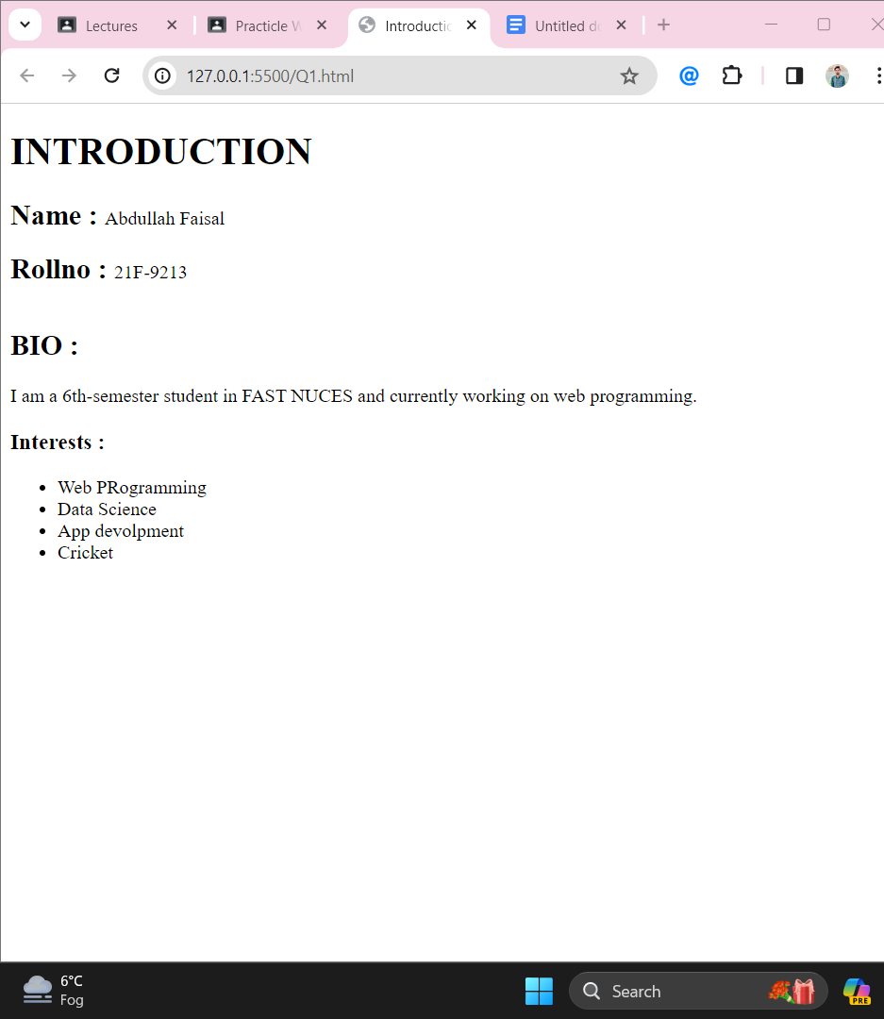

Q2:

<!DOCTYPE html>

<html lang="en">

<head>

<meta charset="UTF-8">

<meta name="viewport" content="width=device-width, initial-scale=1.0">

<title>HTML FORMATTING</title>

</head>

<body>

<b style="font-size: xx-large;">This text is bold</b><br><br>

<strong style="font-size: xx-large;">This Text is Strong</strong><br><br>

<big style="font-size:x-large;">This text is big</big><br><br>

<i style="font-size: x-large;">This Text is italic</i><br><br>

<em style="font-size: x-large;">This text is emphasized</em><br><br>

<output style="font-size: x-large;">This is computer output</output><br><br>

<p>This is <sub>subscript</sub> and <sup>superscript</sup></p>

</body>

</html>

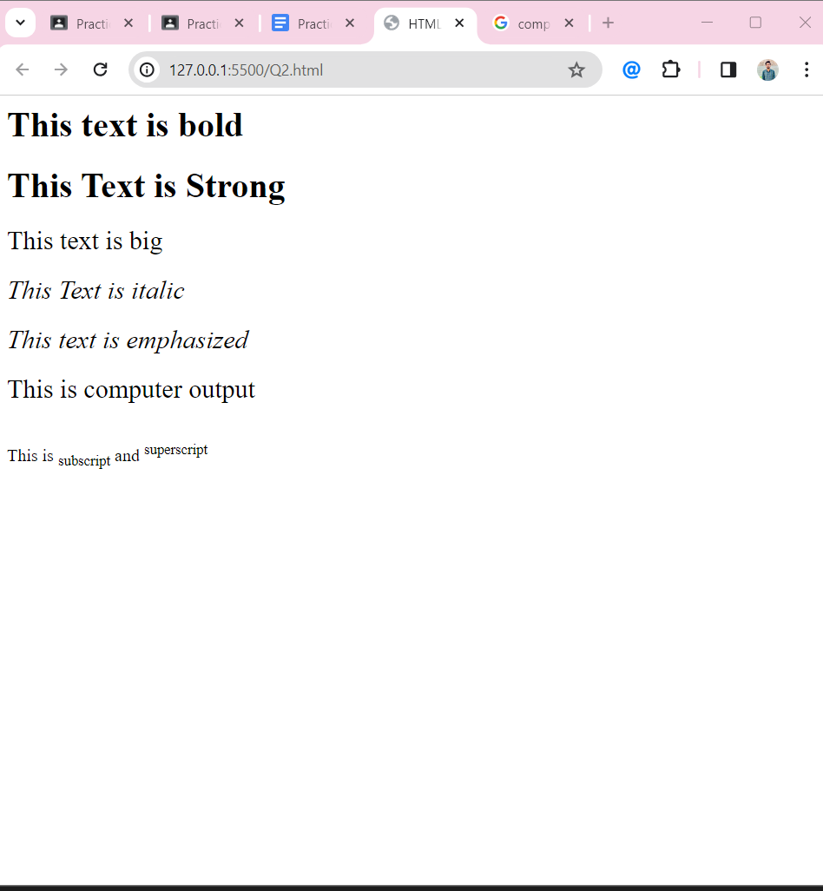

Q3:

<!DOCTYPE html>

<html lang="en">

<head>

<meta charset="UTF-8">

<meta name="viewport" content="width=device-width, initial-scale=1.0">

<title>FAST LOGO</title>

</head>

<body>

<center><img src="National_University_of_Computer_and_Emerging_Sciences_logo.png" alt="Failed to load Image" width="500" height="500"></center>

</body>

</html>



Q4:

<!DOCTYPE html>

<html lang="en">

<head>

<meta charset="UTF-8">

<meta name="viewport" content="width=device-width, initial-scale=1.0">

<title>FAST EBSITE</title>

</head>

<body>

<a href="https://www.nu.edu.pk/" target="_blank"><center><img src="National_University_of_Computer_and_Emerging_Sciences_logo.png" alt="Failed to load Image" width="500" height="500"></center></a>

</body>

</html>





Q5:

<!DOCTYPE html>

<html lang="en">

<head>

<meta charset="UTF-8">

<meta name="viewport" content="width=device-width, initial-scale=1.0">

<title>HTML LIST</title>

</head>

<body>

<h1>HTML Lits</h1>

<h2>Unordered List</h2>

<p>We have books on a variety of languages

<ul>

<li>Oracle</li>

<li>Java</li>

<li>HTML</li>

<li>CSS</li>

</ul>

</p>

<h2>Orderes List</h2>

<p>Follow thses steps to install Java

<ol>

<li>Download the software</li>

<li>Extract to a folder</li>

<li>Double click the executable to run</li>

</ol>

</p>

</body>

</html>

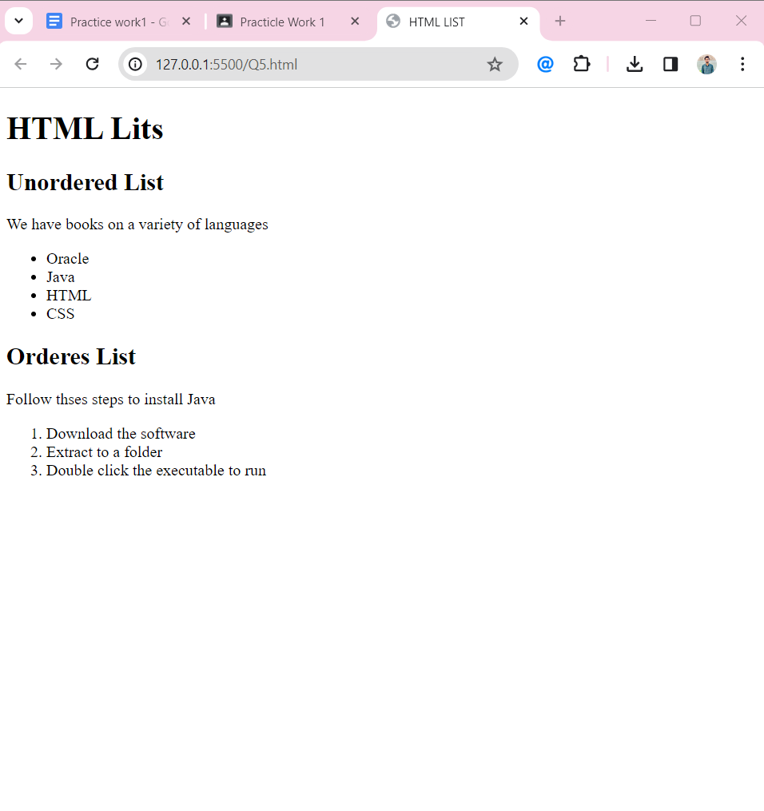

Q6:

<!DOCTYPE html>

<html lang="en">

<head>

<meta charset="UTF-8">

<meta name="viewport" content="width=device-width, initial-scale=1.0">

<title>TABLE</title>

</head>

<body>

<table border="1" style="border-collapse: collapse;">

<tr>

<th rowspan="3">APRIL</th>

<td> hiofhodhsdo</td>

<td>iorhfokhfod</td>

</tr>

<tr>

<td>kjhkjdfh</td>

<td>hdsfk</td>

</tr>

<tr>

<td>lkjdfslk</td>

<td>kndfslk</td>

</tr>

<tr>

<td>lkjdfslk</td>

<td>kndfslk</td>

<td>kjgfvkj</td>

</tr>

<tr>

<td>lkjdfslk</td>

<td>kndfslk</td>

<td>kjgfvkj</td>

</tr>

</table>

</body>

</html>

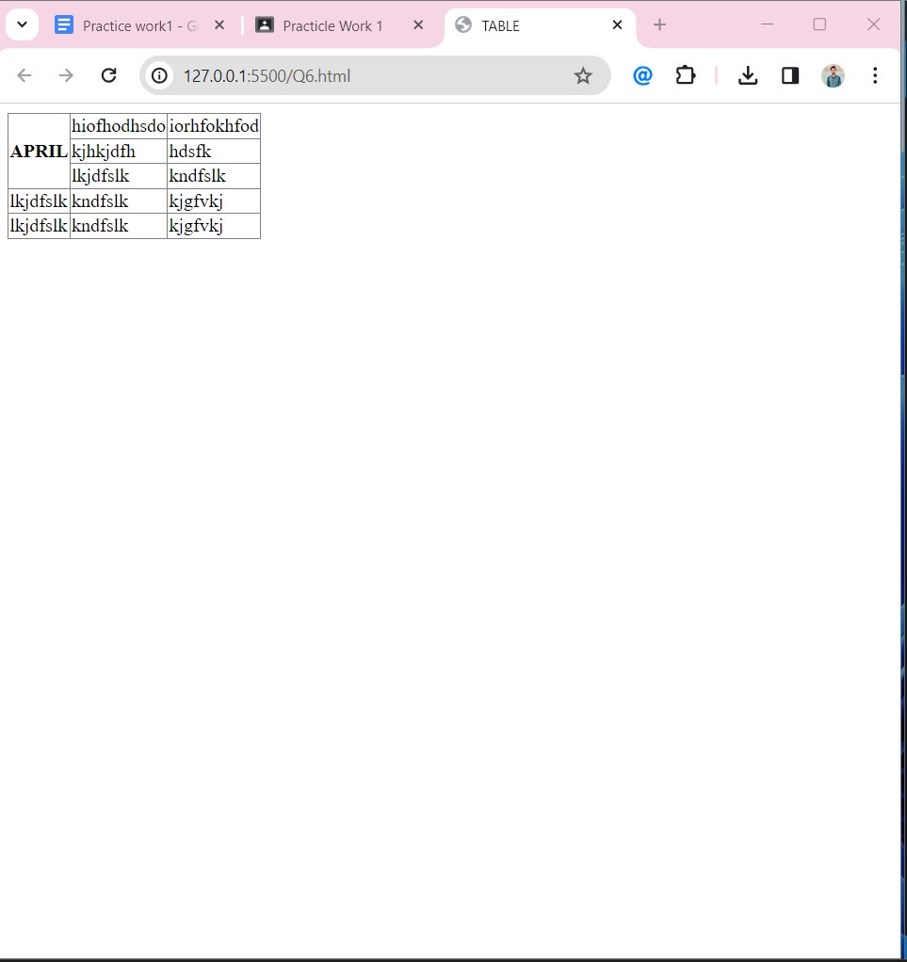

Q7:

<!DOCTYPE html>

<html lang="en">

<head>

<meta charset="UTF-8">

<meta name="viewport" content="width=device-width, initial-scale=1.0">

<title>TABLE 2</title>

</head>

<body>

<table border="1" style="border-collapse: collapse;">

<tr>

<th colspan="3">2022</th>

</tr>

<tr>

<td>daira</td>

<td>icit</td>

<td>speed</td>

</tr>

<tr>

<th colspan="2" rowspan="2">FIESTA</th>

<td>abcd</td>

</tr>

<tr>

<td>jkl</td>

</tr>

<tr>

<td>Lorem ipsum dolor sit amet.</td>

<td>Lorem ipsum dolor sit amet.</td>

<td>Lorem ipsum dolor sit amet.</td>

</tr>

</table>

</body>

</html>

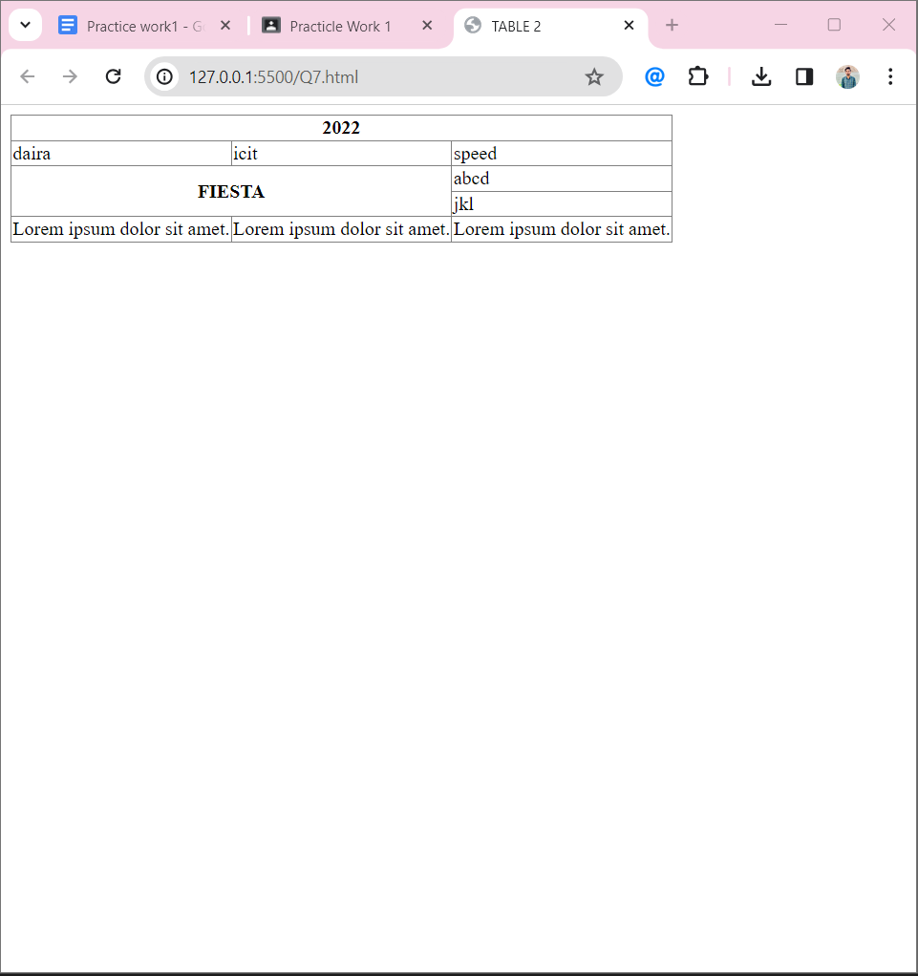

Q8:

<!DOCTYPE html>

<html lang="en">

<head>

<meta charset="UTF-8">

<meta name="viewport" content="width=device-width, initial-scale=1.0">

<title>Input Form</title>

</head>

<body>

<form>

<fieldset><p style="font-weight: bold;">Login FORM</p> <br><br>

<label for="username">Username : </label>

<input type="text" name="username">

<br><br>

<label for="email">Email; : </label>

<input type="email" name="email">

<br><br>

<label for="password">Password : </label>

<input type="password" name="Password">

<br><br>

<label for="confrim">Confrim Password : </label>

<input type="password" name="confirm">

<br><br>

<input type="submit"> <input type="reset">

</fieldset>

</form>

</body>

</html>

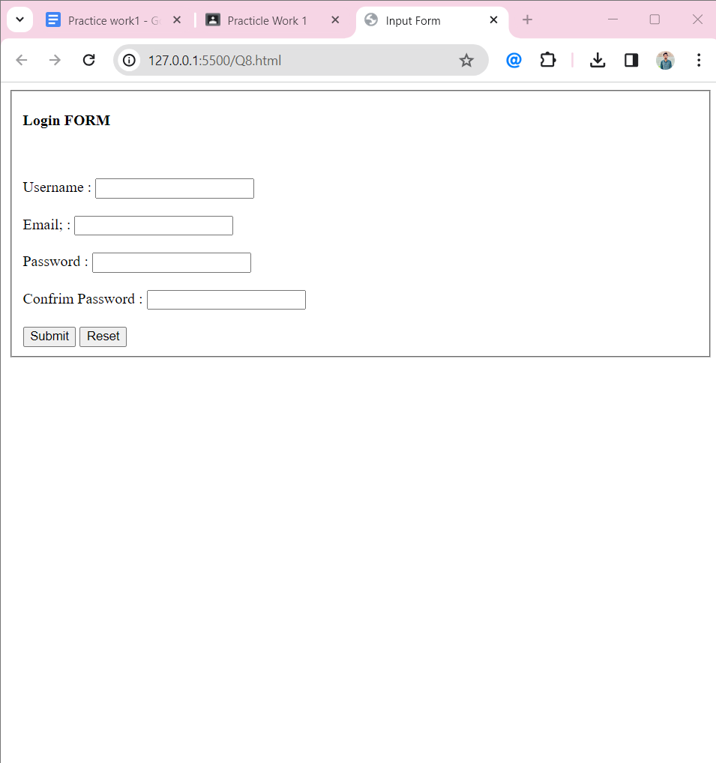

Q9: